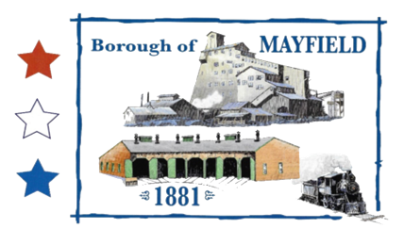
MAYFIELD BOROUGH
PLANNING COMMISSION
739 PENN AVE.
MAYFIELD, PA 18433

MINUTES Of A MEETING OF THE MAYFIELD BOROUGH PLANNING COMMISSION

MEETING DATE: April 6, 2022

CALL TO ORDER: Mr. Zeshonski at 7 pm

PLEDGE OF ALLIEGANCE

ROLL CALL: Mr. Baldan – P Mr. Chelik – P
Mr. Jaskowiec – P Mr. Perry – P Mr. Zeshonski – P

PUBLIC INPUT ON THE AGENDA:

MINUTES OF PREVIOUS MEETING:

MOTION: Mr., 2ND: Mr., to approve the minutes of the Feb 2, 2022 meeting – Motion Carried

OLD BUSINESS:
Zoning change from RC to M1 has been passed by council

NEW BUSINESS:
Mayor Chelik spoke on a meeting with a developer interested in purchasing a parcel of land off of Exit 5 on the Casey Highway. The developers would like to erect two (2) buildings in the borough and one (1) in Archbald. In order to develop the land they would like the zoning designation changed from RC and IAC to M-1.

MOTION: Mr., 2ND: Mr., to adopt resolution 01-2022 designating the following parcels blighted or deteriorated areas:
0640302000101 100.6 A
07402010001 78.8 A
07402010002 164.7 A
07040410002 2.1 A
07401010002 201.9 A
7503010004 1.838 A

MOTION: Mr., 2nd: Mr. to reaffirm our support for the zoning change requested from RC zone to M-1 on the easterly side of the Casey Highway between Exit 5 and the area previously rezoned RC to M-1 near Meredith St.

PUBLIC INPUT:

MOTION TO ADJOURN:
Motion: Mr. Chelik, 2nd: Mr. Jaskowiec, to adjourn. Motion Carried

