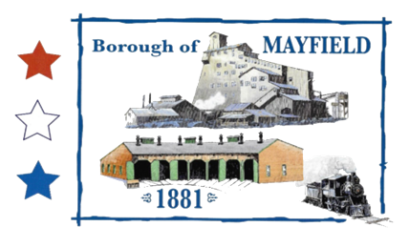
MAYFIELD BOROUGH
PLANNING COMMISSION
739 PENN AVE.
MAYFIELD, PA 18433

MAYFIELD BOROUGH PLANNING COMMISSION MEETING AGENDA

DATE OF MEETING: 5/4/2022

CALL TO ORDER:

PLEDGE OF ALLIEGANCE

ROLL CALL:

PUBLIC INPUT ON THE AGENDA:

ACCEPT PREVIOUS MINUTES:

OLD BUSINESS:

Langan Development

Century Development – Mayfield Logistics Center

NEW BUSINESS:

Bednash Subdivision

Any new business that should be raised by the general public

PUBLIC INPUT:

MOTION TO ADJOURN:

