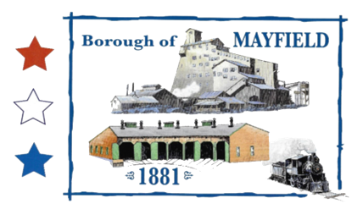
MAYFIELD BOROUGH
PLANNING COMMISSION
739 PENN AVE.
MAYFIELD, PA 18433

MAYFIELD BOROUGH PLANNING COMMISSION MEETING AGENDA

PUBLIC HEARING ON DESIGNATION OF BLIGHTED OR DETERIORATED AREA

DATE OF MEETING: 4/6/2022

CALL TO ORDER:

PLEDGE OF ALLIEGANCE

ROLL CALL: Mr. Baldan – Mr. Jaskowiec –
Mr. Chelik – Mr. Perry – Mr. Zeshonski –

PUBLIC INPUT:

MOTION TO ADJOURN:

