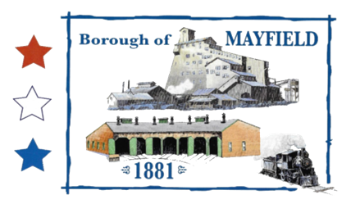
MAYFIELD BOROUGH
PLANNING COMMISSION
739 PENN AVE.
MAYFIELD, PA 18433

MAYFIELD BOROUGH PLANNING COMMISSION MEETING AGENDA

DATE OF MEETING: 4/6/2022

CALL TO ORDER:

PLEDGE OF ALLIEGANCE

ROLL CALL: Mr. Baldan – Mr. Jaskowiec –
Mr. Chelik – Mr. Perry – Mr. Zeshonski –

PUBLIC INPUT ON THE AGENDA:

APPROVAL OF MINUTES:

OLD BUSINESS:

NEW BUSINESS:

Discussion on meeting with developer for an area off of Exit 5 of the Casey Highway

Motion to pass resolution 01-2022, designating a portion of the borough a deteriorated area.

Motion to recommend to council a zoning change from RC zone and IAC zone to M-1 on the easterly side of the Casey Highway between Exit 5 and the area newly rezoned RC to M-1 near Meredith St.

Motion to recommend to council changing the Maximum Building Height in an M-1 area (Table 3, on Page 3-9) of the zoning ordinance from 45’ to 55’.

Motion to recommend to council changing the portion of the parcel number 07401010002 (37.32 acres) west of the Casey Highway and North of Rushbrook St. from R-1 to R-2.

Motion to recommend to council to add Indoor Shooting Range to a C-2 zone.

PUBLIC INPUT:

MOTION TO ADJOURN:

